**Creating a work google account so you can view YouTube videos**

**In your web browser…** [**https://accounts.google.com/**](https://accounts.google.com/)

**Put your compass email address in the box that appears.**

**Although it is not a personal account, click as below (this avoids paying for an account)**

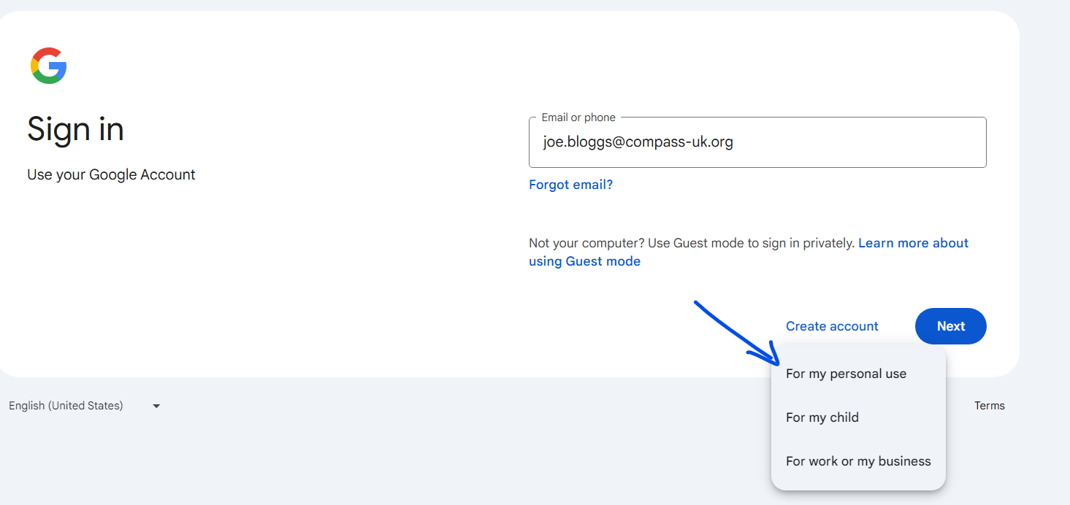

**Fill in your name in the next screen, press next**

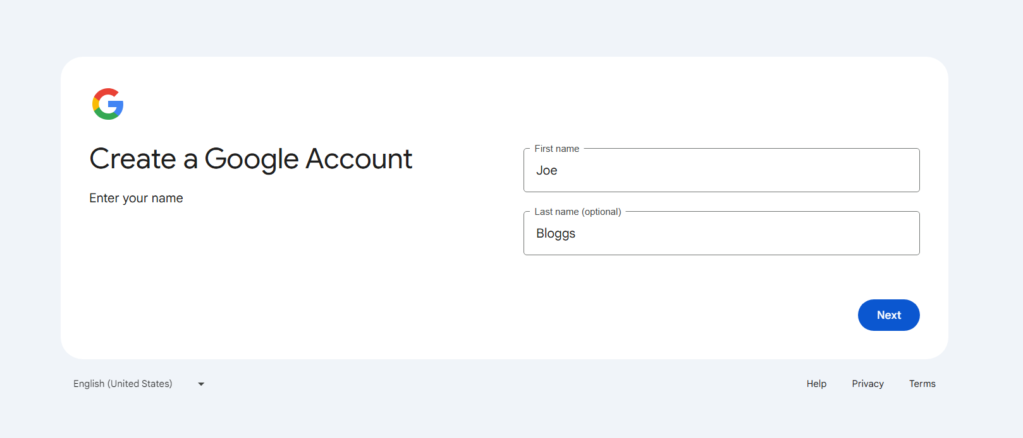

**Fill in basic info how you prefer. Press next.**

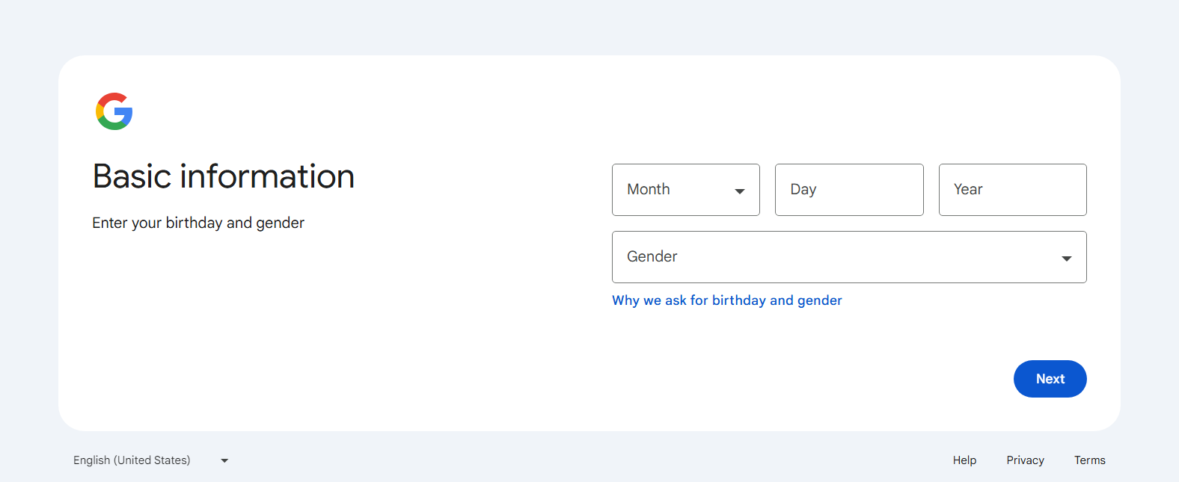

**You can now enter your existing compass email address or choose to make a gmail address, such as** [**joebloggscompass@gmail.com**](mailto:joebloggscompass@gmail.com)**.**

**Press next.**

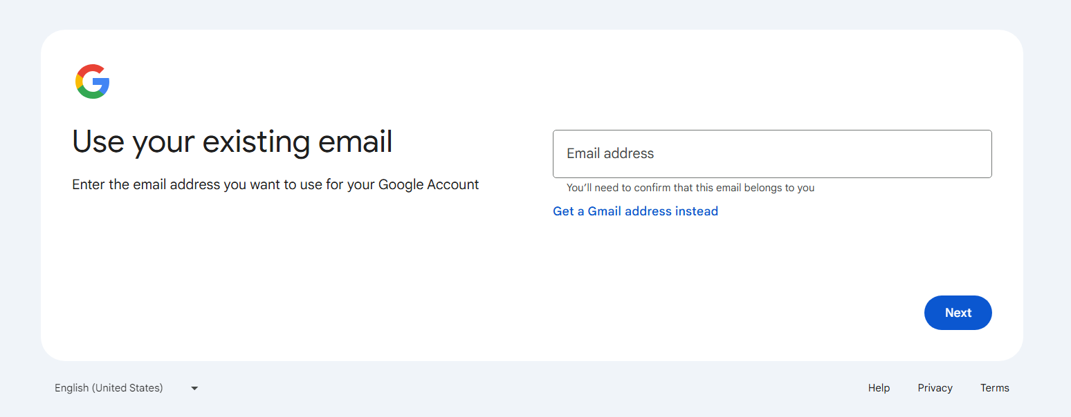

**If you choose to use your Compass email address, you will receive a six digit verification code. Put it in the box and press next.**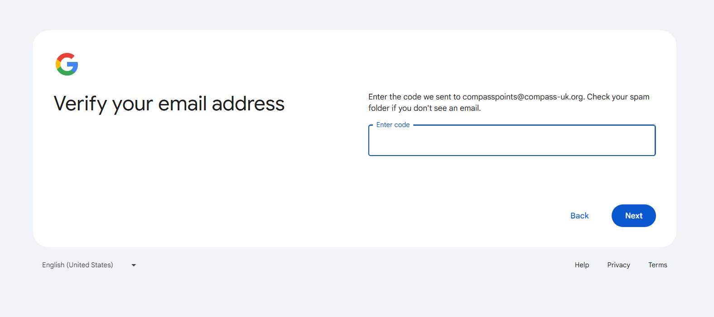

**You can now sign in to google using the same web address of** [**https://accounts.google.com/**](https://accounts.google.com/)