Our service provides universal early help and intervention to children, young people and their families on a range of health and wellbeing issues. All referrals will be triaged by a Nurse and referrals which fall outside of our service offer will not be accepted and will be returned to the referrer (Please see Connect for health’s referral criteria). Professionals, parents/carers and young people can contact the service to discuss our service offer on 03300 245 204.
Privacy Notice Statement Please note by completing this referral, Compass will expect that:

- This referral has been discussed and agreed by the service user

- You consider the service user to have capacity to give informed consent
- You have explained that any information held on this form will be stored

by Compass on a secure database

Signed by referrer…………………………………………………………….…………………………………………………………..………
Signed by service user……………………………………………………………………………………………………………………..
(parent/carer or young person)

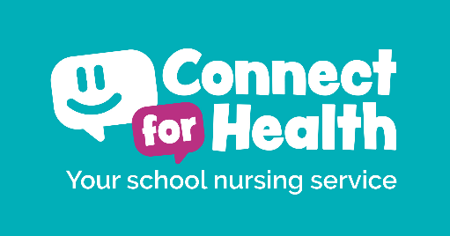
Connect for Health Referral Form
CONFIDENTIAL
Child/Young person’s Name: |  |  |  |  |  |  | NHS Number:
Date of Birth: |  |  |  |  |  |  | Gender:
Address:
 | Post Code:
School: |  |  |  |  | Year Group:
Ethnic Origin: | African |  |  | Bangladeshi |  | Caribbean |  |  |  | Chinese
 | Indian |  |  | Pakistani |  | White and Asian |  |  |  | White and Black African
 | White and Black Caribbean |  |  | White British |  | White Irish |  |  |  | Other
 | Other Asian |  |  | Other Black |  | Other White |  |  |  | Other Mixed
Parent/Carer Name:
Contact Number:
Email Address:
Young Persons mobile number:
(Secondary School Aged Only)
Has Consent been obtained from: |  | Parent/Carer |  |  |  |  |  | Young Person

GP Details:
Current Safeguarding Status – service user currently open to: |  |  | Early Help |  |  |  |  |  | CIN |  |  |  |  | CIC |  |  | CP
Social Worker Name |  |  |  |  |  |  |  |  |  | Next Safeguarding Meeting (Date)
Does the child/young person have any Special Educational Needs? (SEND) |  |  | Yes |  |  | No |  |  |  |  | If Yes, please advise below:
Does the child/young person have any disabilities? |  |  | Yes |  |  | No |  |  |  |  | If Yes, please advise below:
Is the child/young person currently being supported by any other professional/service? |  |  | Yes |  |  | No |  |  |  |  | If Yes, please advise below:
Support needed from: |  |  |  | School Nurses |  |  |  |  |  |  |  |  | Change Makers
Reason for Referral:
Referrer Name:
Designation and Organisation:
Referrer Address:
Email Address:
Contact Number:
Date of Referral:
PLEASE FORWARD YOUR COMPLETED REFERRAL FORM SECURELY
Connect For Health
Address: | Valiant Office Suites, Lumonics House, Valley Drive, Rugby CV21 1TQ.  Telephone: 03300 245 204
Secure emails: | connectforhealth@compass-uk.org (with an Egress account)  connectforhealth@welearn365.com  compass.connectforhealth@nhs.net

