Compass REACH supports children and young people aged 9 – 19 (up to 25 for those with special educational needs or disabilities) with mild to moderate emotional wellbeing and mental health issues.

Our dedicated team of Emotional Wellbeing Practitioners provide time-limited one-to-one or group work sessions (usually around six), these are designed to support children and young people make improvements to their long-term health, resilience, and emotional wellbeing.

If you have any difficulty, or need support completing this form, please contact us on 01904 661916 and we will be happy to help in any way we can.
So that we can make sure you get the right help we need to know a little bit more about your child.

Who is making this referral?

I am the parent/carer or significant other of the child/young person Yes ☐
Does the child/young person agree to this referral? Yes ☐ No ☐

Details of the child/young person

Name
Address and postcode
Contact phone number
Date of Birth |  | Age

Details of parent/carer or significant other
Name
Address and postcode

Contact phone number

Name of G.P surgery
Name of school/college

Please provide some additional information about what your child/young person would like support with:

Please indicate what the main problem seems to be:

Stress | ☐ | Feelings of anger | ☐
Bullying | ☐ | Self-harm | ☐
Anxiety | ☐ | Body image | ☐
Low mood | ☐ | Eating problem | ☐
Self-esteem | ☐ | Bereavement/loss | ☐
Social Isolation | ☐ | Suicidal thoughts | ☐
Other (please give details):

On a scale of 1 – 10, please indication how much this problem impact on the child/young person’s ability to go about their day-to-day life:

1 being not at all, and 10 being very much
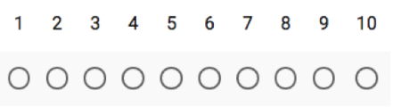
Not at all Very much

Consent Statement
By completing and submitting this form you are giving your consent for Compass to store the information held on this form on a secure database.

Please email your completed Request for Support form to: nyrbs@compass-uk.org
Once in receipt of your email Compass store client information securely however Compass cannot accept responsibility for the security of your details while the email is in transit.

